Ozonesonde station: Madrid. Spain. Instituto Nacional de Meteorología (INM). April 2005.

Site

From 25 March 1992, a weekly ozone sounding was performed in Madrid by the Spanish National Meterological Institute (INM). Some intensive campaigns were done on February and June 1995. From the beginning until 5 February 1997 launches were done at the same site of the Brewer Mark IV number 070 and corresponding to the National Radiometric Center (WOUDC site n. 308), latitude 40º 27´ N, longitude 3º 43´W, altitude 680 m ASL. From February 1997 until now, launches were done at the site of synoptic weather station WMO code 08221 where conventional radio sounding activities are routinely done at 40º 28´ N and 3º 35´ W, altitude 631 m ASL. Activities of ozonesondes were regularly performed by INM also at St. Cruz de Tenerife in Canary Islands, related with the national and international activities of Izaña Atmospheric Observatory.

Instruments:

Ozonesondes are of the type Electrochemical Concentration Cell (ECC) and are coupled with a modified Vaisala RS-80 (RS80-15G) in the flight. Such procedure allows the obtention of windspeed, temperature and moisture vertical profiles measured simultaneously as ozone.

Data are received and procesed by a Digicora Marwin-11 station. Distilled water is actually used but we consider the use of deionized water in the future. Calibration Unit is a TSC-1. Ozonosonde is a SPC-6A. Radiosonde used is RS80 modified (RS80-15G).

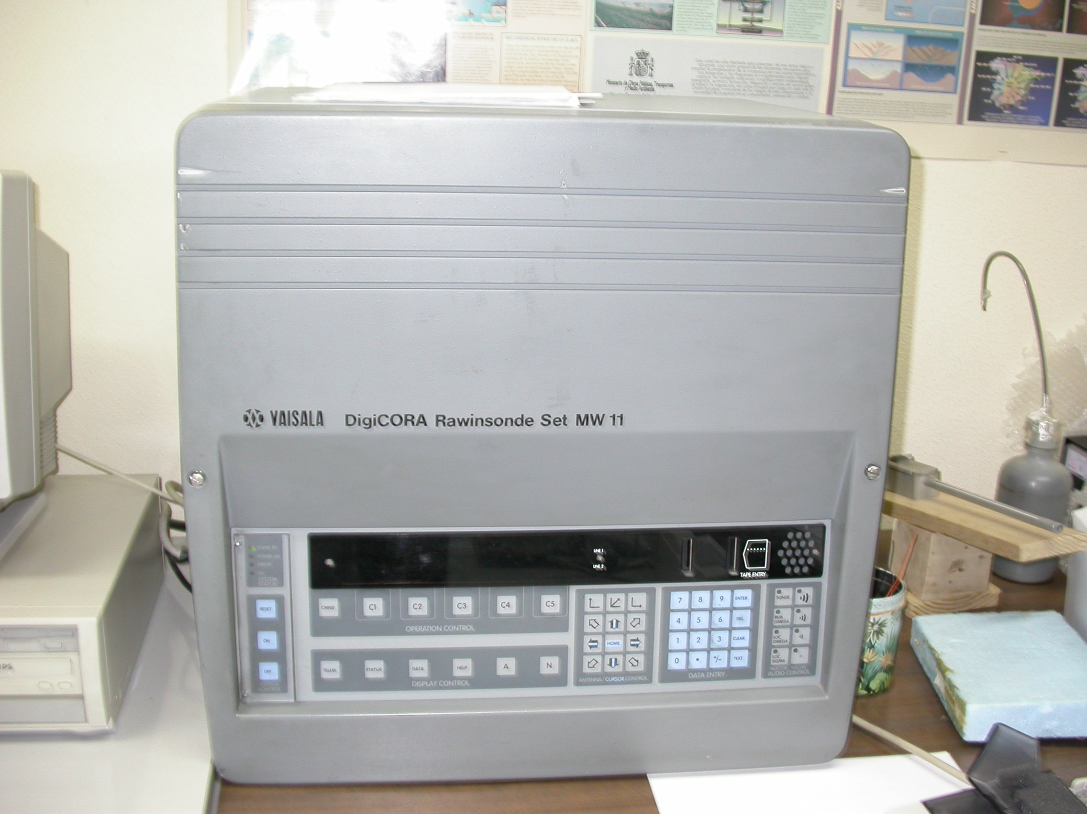
Activities 3-7 Days Prior To Release

- Charge sensor cathode with solution: 3.0 cm³
- Charge sensor anode with solution: 1.5 cm³.
- Sensor background current after 5 min on NO O₃.
- Ozone Interface 01F11
- 1200 gr Balloon

Preparations just before (0-2 h) balloon release

- Change cathode solution in SONDE and CALIBRADOR
- Sensor background currents (<0.2 µA).
- Condition SONDE and CALIBRATION sensors with 5 ±µA O₃ for 10 min.
- Add ozone sensor to interface card and check overall system operation.
- Run ozonesonde for 10min (with ozone destruction filter on) for sensor background valúes:
- Background sensor current <0.2 µA).
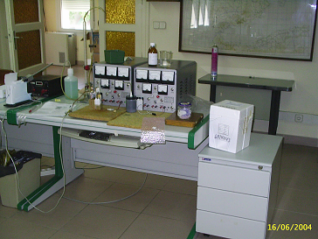

Cathode solution

Preparation of cathode solution at 1% KI , is as follows:
Put bidistilled water 500 ml, in on a flask , and then add:

- 10.00 g KI
- 25.00 g KBr
- 1.25 g NaH₂PO₄. H₂O
- 5.00 g Na₂HPO₄. 12H₂O, or 3.73 g Na₂HPO4. 7H₂O.

Shake it until solved and then complete with bidistilled water to reach 1000 ml of solution.

Anode Solution

Add 90 g KI to 50 ml of cathode solution and then shake it strongly until reach saturation of KI . A surplus of KI will remain always due to saturation.

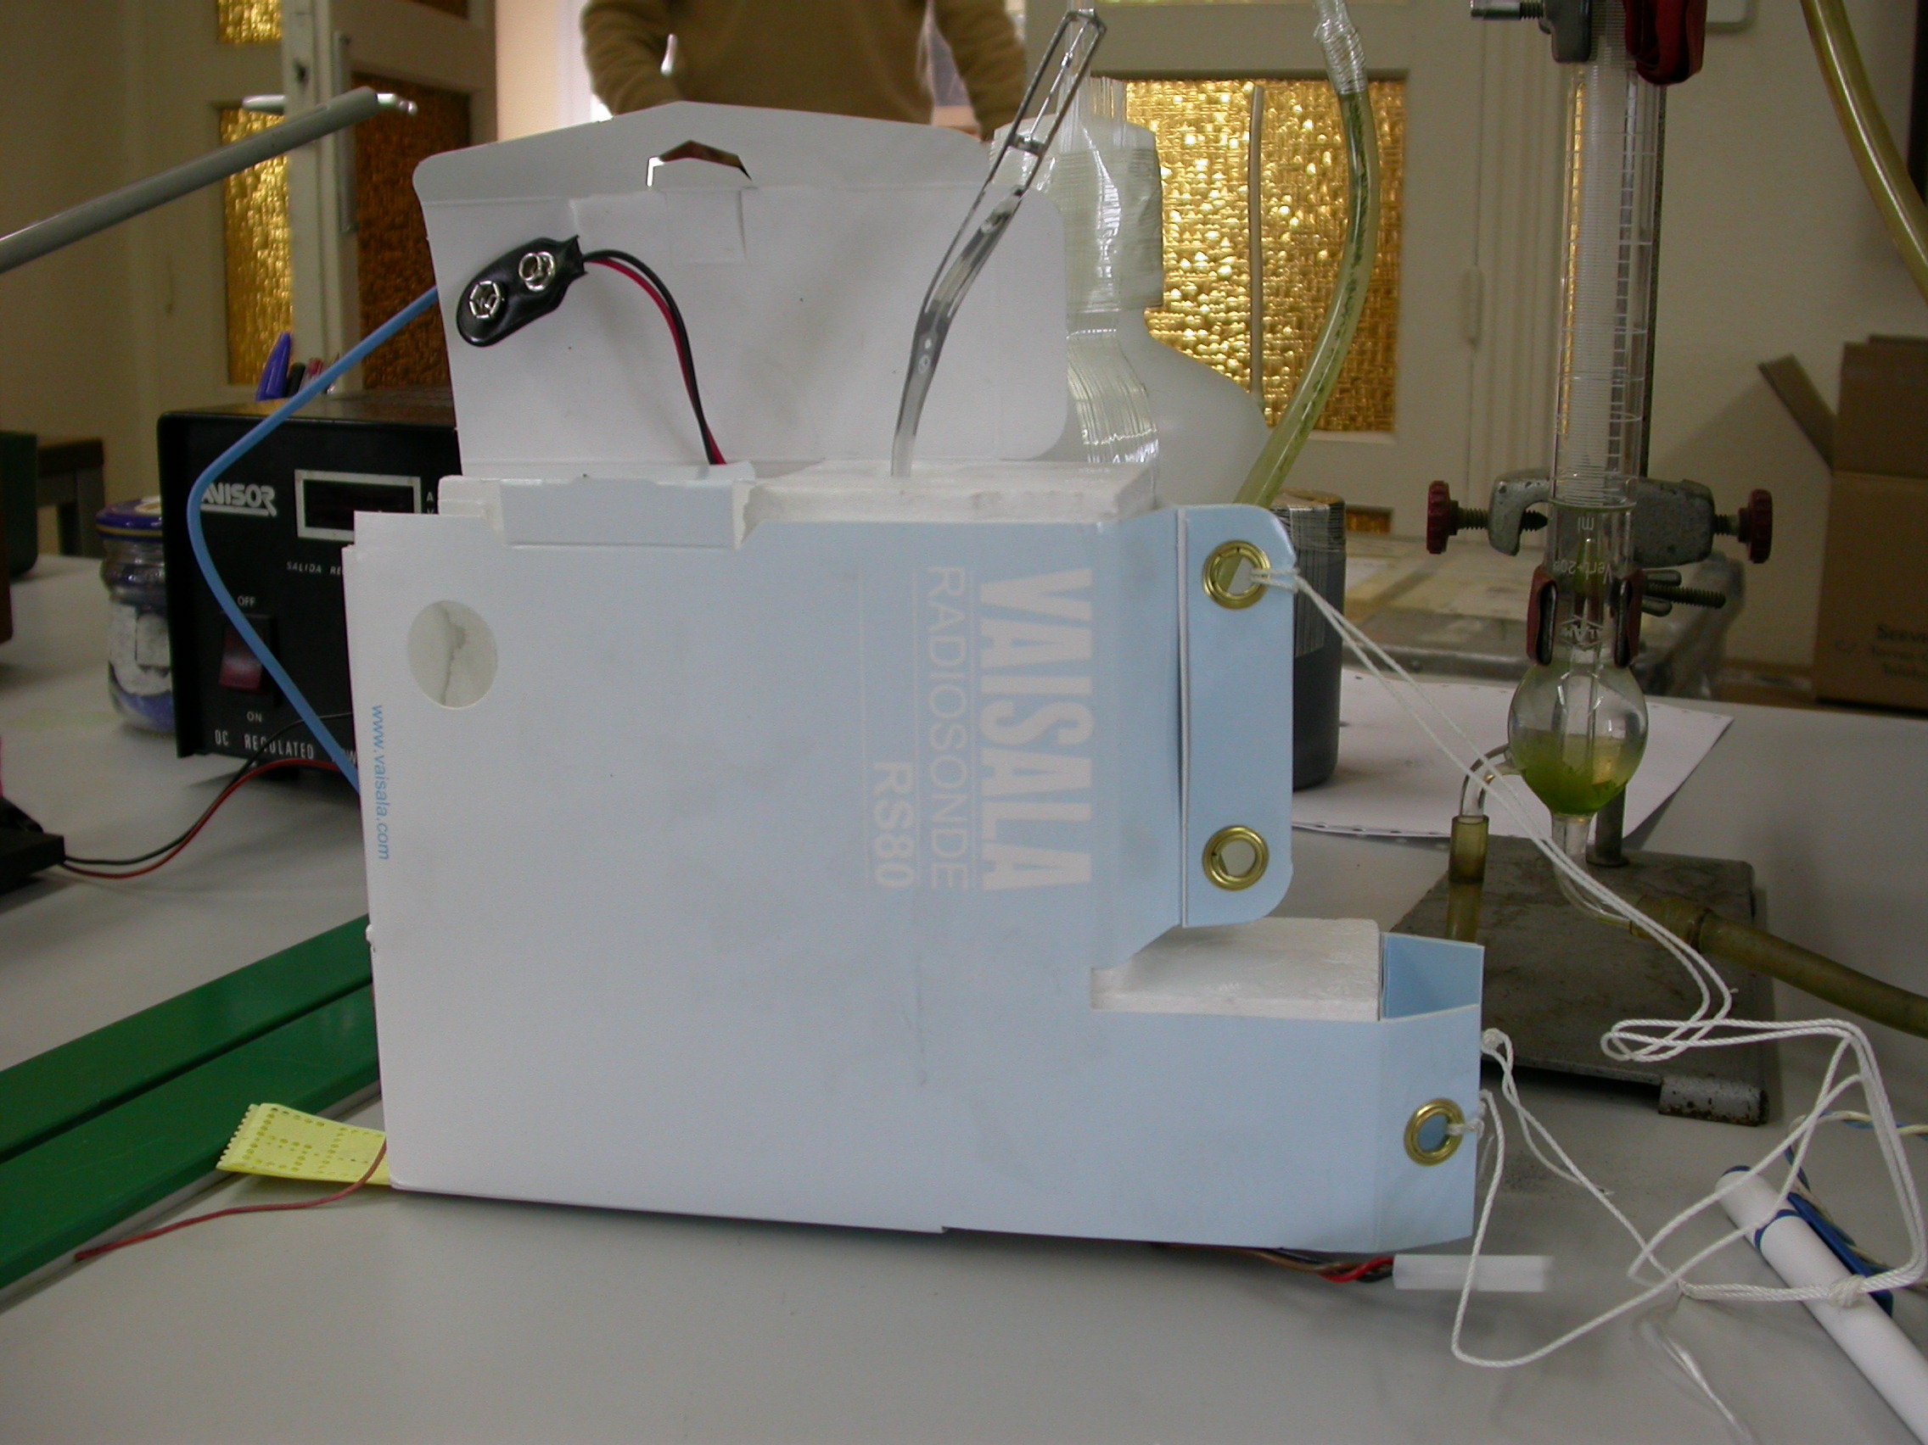

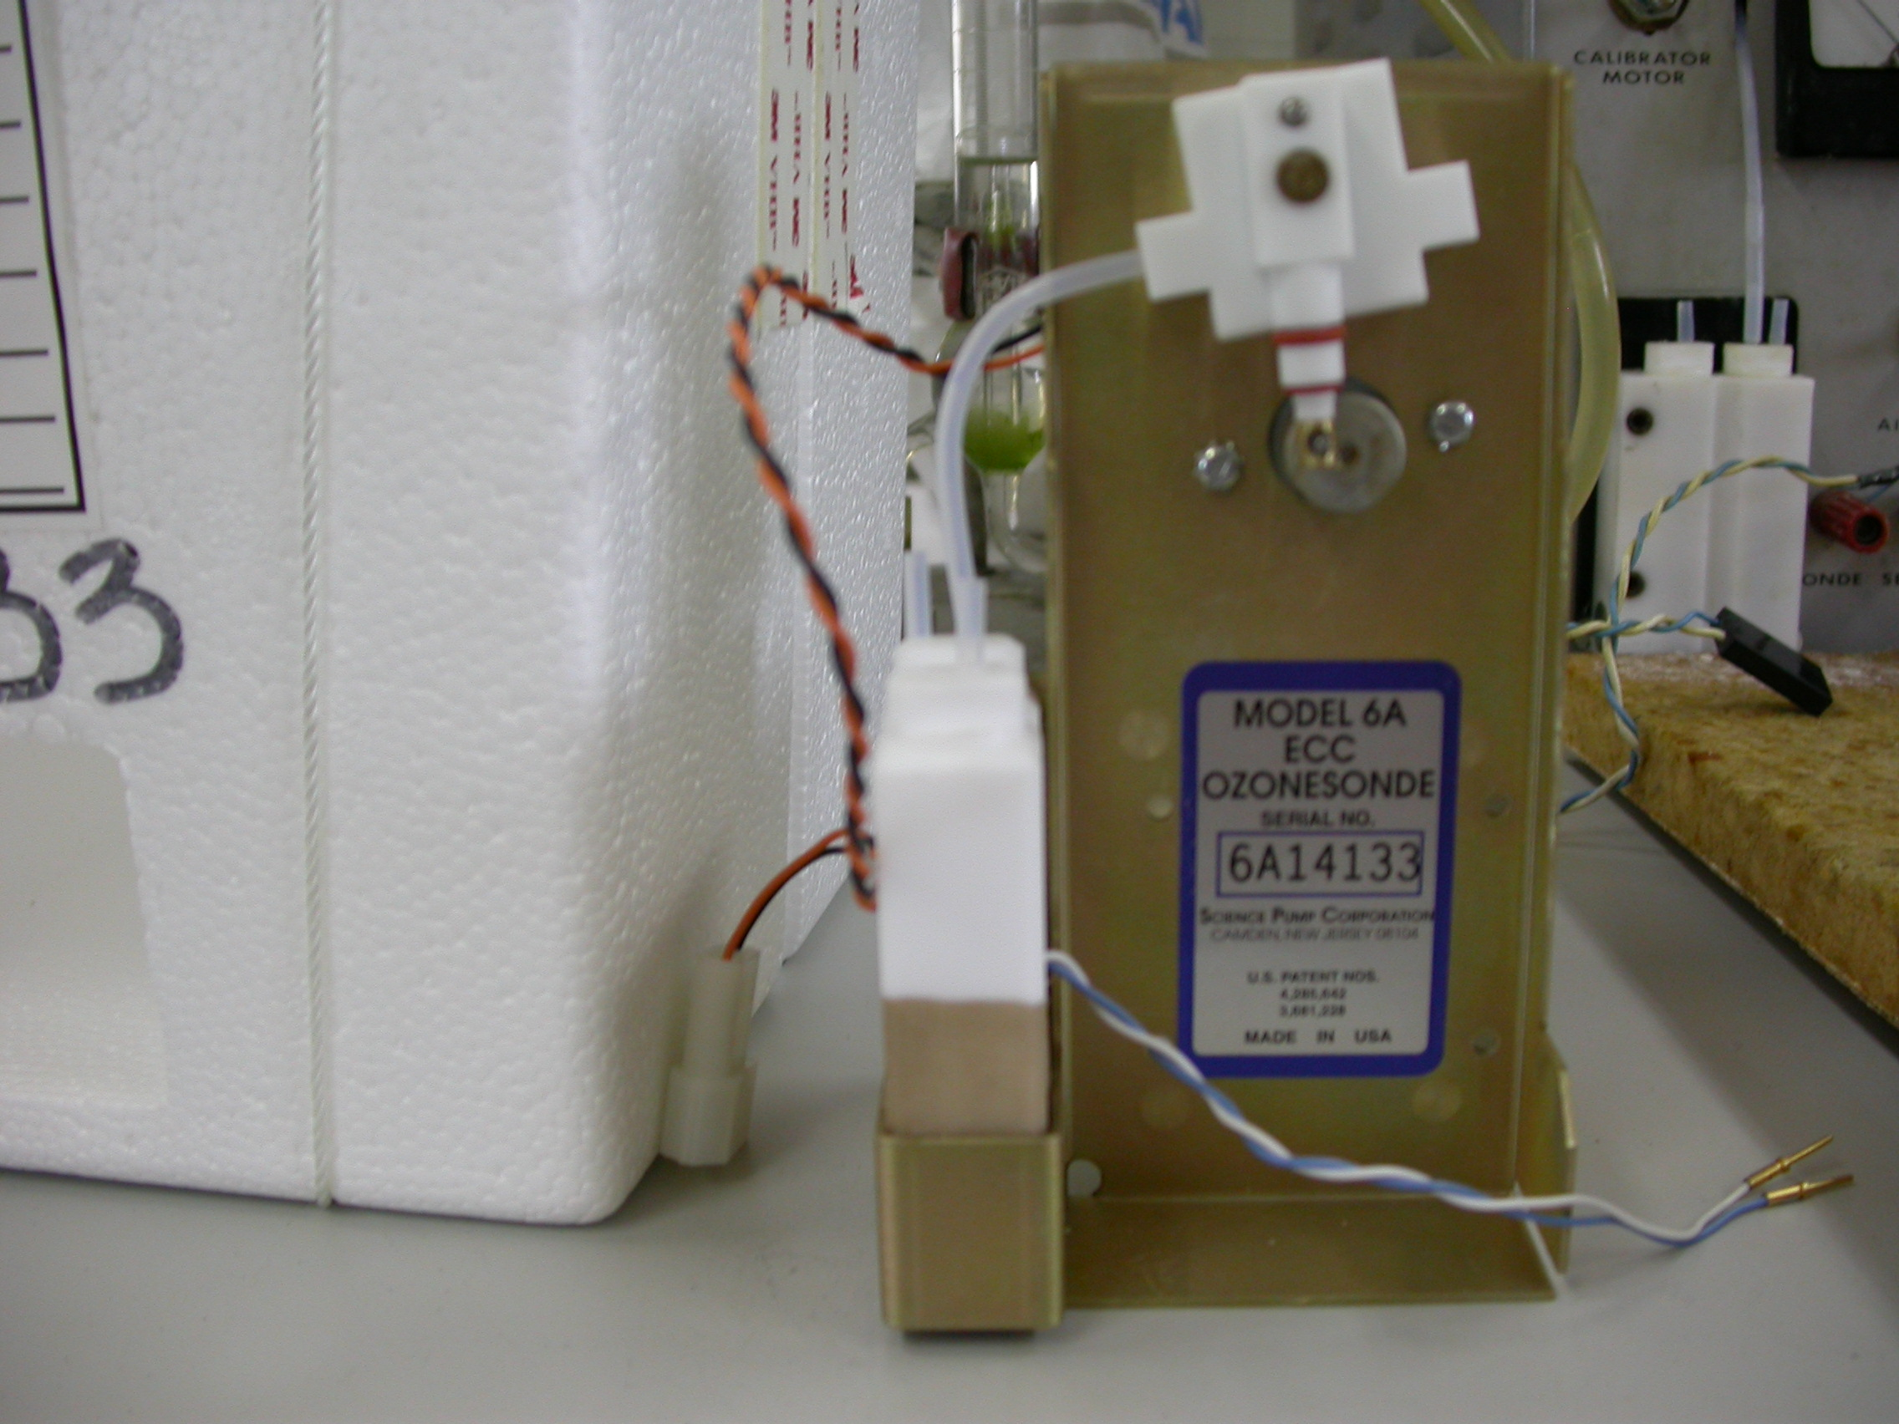

Data quality control methodology.

From 1992 to 2002 a grand total of 460 ozonesoundings were done. This period was used in a first step towards a knowledge of the ozone vertical profile over the centre of Iberian Peninsula. A internal work was published (Gómez and Labajo, 2004) and some of the results were published at EGU Meeting in Vienna in April 2005 ( Gómez, I., A.Labajo and J.Camacho. “ Analysis of stratospheric ozone over Iberian Peninsula” ).

Period |  | N. of soundings
Year | 1992 | 38
Year | 1993 | 49
Year | 1994 | 5
Year | 1995 | 87
Year | 1996 | 57
Year | 1997 | 58
Year | 1998 | 55
Year | 1999 | 30
Year | 2000 | 9
Year | 2001 | 38
 | 2002 | 40
Month | 1 | 37
Month | 2 | 51
Month | 3 | 31
Month | 4 | 37
Month | 5 | 39
Month | 6 | 52
Month | 7 | 38
Month | 8 | 33
Month | 9 | 37
Month | 10 | 33
Month | 11 | 32
Month | 12 | 40
Table 1. Year distribution on ozonesoundings

Distribution of the launches over the time period was not uniform as it could be seen in the previous Table 1. Only 5 soundings were performed in 1994 and, in contrast, 87 in 1995.

Quality control consists into the comparison between integrated ozone profile and the Total Ozone value provided by Brewer spectrophotometer installed at National Radiometric Center in Madrid. Only when the balloon reachs 17hPa the integration is made, because it is necessary to compute the total ozone above balloon burst altitude extrapolating the ozone mixing ratio at burst altitude to the top of the atmosphere.

Ozone soundings whose k differs in 3σ of the mean were rejected. After selection, total ozone ratios obtained from ECC and Brewer instrument, k, show a good agreement between both measurementes, as it can be observed in table 2. The k mean for all profiles (selected and unselected) was 1.003 ± 0.095.

K | Num. Sond.
0,83-0,91 | 19
0,91-0,98 | 97
0,98-1,05 | 143
1,05-1,12 | 46
1,12-1,20 | 8
Table 2. Total ozone ratios

Years 2003 and 2004 are under revision at that moment due to several changes in the team that perform the ozonosoudings. A new method for comparation between Madrid ozonosoundings and Brewers in Iberia: Murcia, Zaragoza, Arenosillo and Coruña has been developed due to the troubles experiencied by the original source of comparison: the Brewer 070 in Madrid that also needs a revision in data from that period.

Actual method is as follows: Obtention of difference between Ozonosonde integrated total ozone and Madrid Brewer total ozone product normalized by division by a mean climatological value: 313,3 D.U for Madrid. Final result is expressed in percentage. Same procedure is applied to TOMS values. A last comparison between TOMS and Brewer total ozone as cross check is also issued.

As Madrid Brewer expererienced some troubles, an statistical relationship between Madrid and Murcia (site at 300 km southeastward from Madrid) was obtained in orde to ensure a second level for comparisons.

Comparisons between Madrid integrated total ozone and Brewer for 2004 showed a positive difference of 10% due probabily to a double concentration in the cathode solution and buffer solution that recommended. Today concentrations are as described previously in this document.

Real-time data and archived data.

Barajas site has ADSL connection. Ozonesounding data are sent to INM Headquarters where are compared with Brewer and TOMS data. After the quality control process, data are stored to be sent to WOUDC in a bi-monthly basis.

A set of data from 1992 to 2002 that had been used for the papers above mentioned and quality controlled is almost ready to be sent after CSV coding.

After a documentation of soundings made from 2003 to 2004, a release of such data will be done.

