Hong Kong Brewer #115 Calibration and Service Report – March 2007

Int’l Ozone Services (IOS) completed the annual calibration and service of Hong Kong Brewer #115 during period April 1-4, 2008. In the past year the standard lamp (SL) ratios had decreased about 1% (-15/-45), to values of 1705/3155, reference graph at bottom of this page. The weather did not co-operate this year for the ozone and UV comparison checks.

Ozone calibration results:
The ETC constants recommended last year were 2968/2915 and last August the ETC’s were adjusted to values of 2938/2858. Below are last year’s final ozone/SO₂ direct sun results from #115 and standard #017

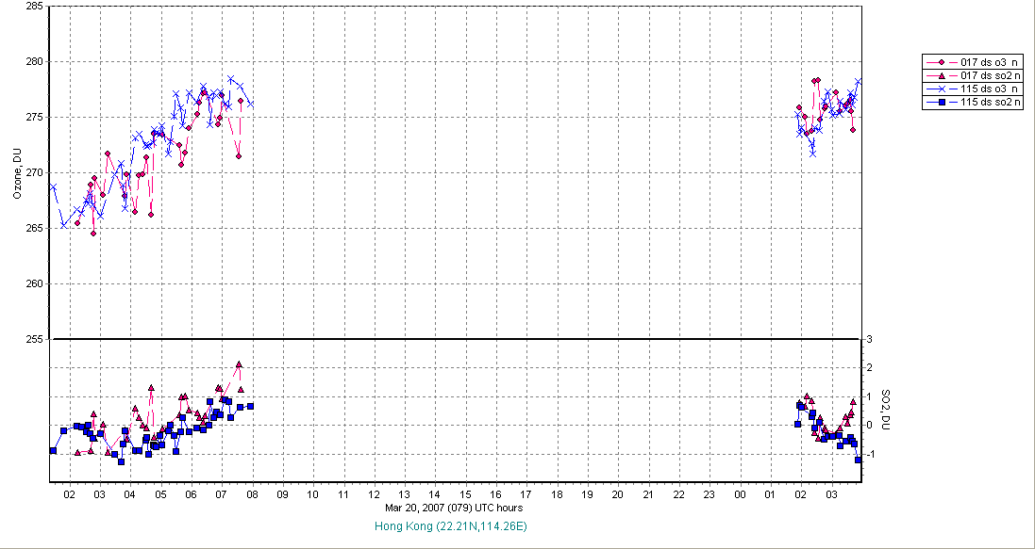

Next are the SL ratios for the past year showing the slow decrease last summer and stabilized at present values in September.

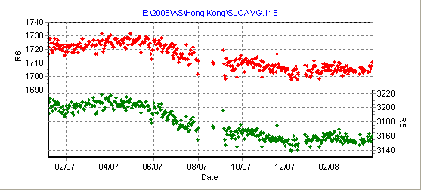

Submitted by Ken Lamb, Int’l Ozone Services Inc. (115cal08.doc) Page 1 of 3
Next are the sun scan results showing that the cal step should be set again back to 292 instead of 290 and this was done. The mercury lamp has been replaced at the start of this year and this may be the reason for shift.

Below are graphs of the stable DT and RS test results for the past year and a scan of standard lamp compared to 2006 scan. Then a CZ scan of Hg 2967A line, which shows normal slit function.
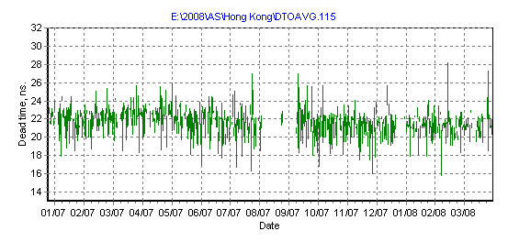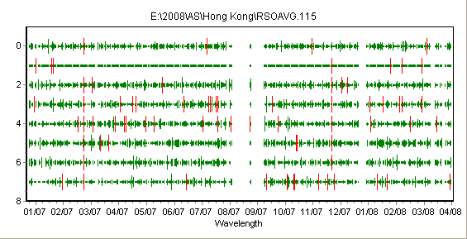

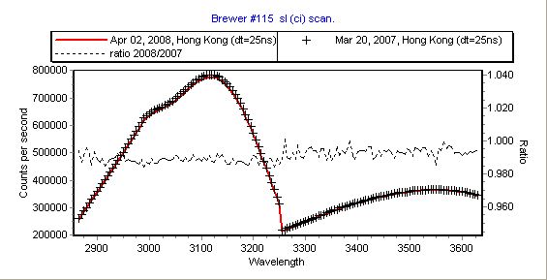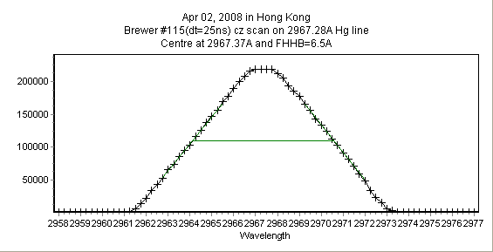

Below are the same O₃ results and the AOD results using 2005 AOD constant (for slit 5 = 79984).

UV Calibration:
The UV calibration was completed and the new response file (uvr09308.115) is recommended for future use. Wavelength accuracy was checked with dispersion test and when processed the results were very similar to constants in use (dcf06205) and so no changes were made.
Below is new response file calculated from IOS lamps #67, #201, #203 - compared to 2006 and 2007 files. The local UV lamps #331, #332 were also measured and showed similar change in sensitivity however if their original 1994 calibration files are used to obtain response file then it’s level is ~5% higher.

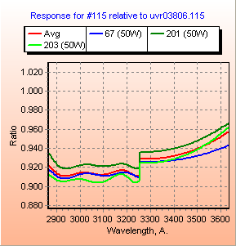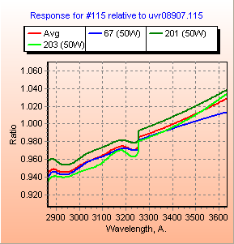

Other calculations and software Recommendations:
1. Revised zenith sky coefficients (file zsf08207.115) were calculated from 2006 data and produced improved ZS data agreement to direct sun results. The program O3brewer.exe is good for re-processing past data with the new ZS coefficients and obtaining final daily mean results with the use of daily standard lamp ratio corrections.

2. The direct sun NO₂ results appear to high especially when compared to the zenith sky results and so it is recommended that the ETC for DS measurements be lowered from 730 to 710. The O3brewer program once again can be used to examine this data. This change was not implemented into constants files during this visit.

3. The new global irradiance (GI) software routine was provided and it was recommended that this measurement be done about twice per hour each day. This new routine records the data into the B-file and the latest O3brewer program can be used to obtain ozone results from this data.

