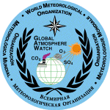


Training on monitoring of total ozone with the Dobson spectrophotometer at the GAW station Kyiv, Ukraine

and

Intercomparison of the Dobson spectrophotometer D040

R e p o r t

Solar and Ozone Observatory (SOO-HK)
Czech Hydrometeorological Institute
Hradec Kralove

19.-30.04.2010

Prepared by:

Karel Vaníček, Ulf Koehler and Robert D. Evans

1. Aim of the action

Based on the bilateral agreement between the:
Royal Meteorological Institute of Belgium (RMIB)
Taras Shevchenko National University of Kyiv (TSNU)
Assisted by:
German Meteorological Service (MOHp)
Czech Hydrometeorological Institute (SOO-HK)
National Oceanic and Atmospheric Administration, USA (NOAA)

The Dobson ozone spectrophotometer No.D040 has been lent by the RMIB to the TSNU. Before the installation of the instrument at the newly established ozone monitoring station in Kyiv the spectrophotometer was refurbished at the MOHp, with installation of new electronics, and alignment and then calibrated against the secondary European reference D074 at the SOO-HK. At the same time the experts of the TSNU were trained in its operation. As a part of a program to better characterize the optical parameters of the Dobson instrument, spectrometric measurements of the slit functions of D040 were also measured by the invited expert of the World Dobson Calibration Centre – NOAA/ESRL/GMD, Boulder, CO. The action was recommended by the SAG-Ozone and organized under the umbrella of the Global Atmosphere Watch Programme (GAW) of the WMO as the activity of the Regional Dobson Calibration Centre – Europe on the capacity building. The chief works on the instrument and activities performed during the Intercomparison and the Training are specified below.
2. Participants

Experts
Mr. Karel Vaníček (CHMI, SOO-HK)
Mr. Martin Staněk (CHMI, SOO-HK)
Mr. Ulf Koehler (DWD, MOHp)
Mr. Robert D. Evans (NOAA, ESRL/GMD)

Trainees
Gennadi Milinevsky
Taras Shevchenko National University of Kyiv Tel: +38 044 526 4457
64, Volodymyrska Str Fax: +38 044 526 4507
01601, Kyiv, Ukraine E-mail: genmilinevsky@gmail.com

Mikhail Sosonkin
Laboratory for Atmosphere Optics Tel/fax: +38 044 526.4761
The Main Astronomical Observatory +38 044 275.5192
National Academy of Sciences of Ukraine E-mail: sosonkin@mao.kiev.ua
Zabolotnogo st.,27
03680Kiev, Ukraine,

3. Program of the action

Venue:
The Solar and Ozone Observatory of Phone: +420-49-5260352
the Czech Hydrometeorological Institute E-mail: vanicek@chmi.cz
Hvezdarna 456, 500 08 Hradec Kralove 8 stanek@chmi.cz
Czech Republic

Training
The training was focused mainly on explanation of the methodology of Dobson observations, operation and maintenance of the instrument and proper use of the operational software at the station. A special attention was paid to improvement of the practice on in-situ measurements at Kyiv and the regular lamp tests including operational correction of the calibration constants (N-Tables, Q-Tables). The following topics were explained, demonstrated and practiced during the training.

  - Theory of measurements
- Physical background and function of the instrument
- Direct sun observations DS, zenith blue ZB and zenith cloudy ZC observations

  - Routine measurements with the Dobson spectrophotometer
- Scheduling of measurements using the CDA sequence
- Reading, recording and archiving of the raw data

  - Maintenance of the instrument and adjustment of constants
- Routine Mercury (HG) lamp tests – verification of wavelength calibration of instrument, and the adjustment of Q-setting tables based on the results, if needed.
- Routine standard lamp (SL) tests – verification of calibration level of instrument, and the correction of N-tables based on the results.
- Cleaning of external parts of the instrument

  - Processing of data with the O3DOBSON software
- Description of the software, installation of the program and setting of basic parameters
- Routine processing of observations, outputs - daily and monthly protocols, PC files, graphs
- Creation of the data reports
- Maintenance of the total ozone data base
- Comparison of Dobson observations with satellite data

  - International data exchange
- Cooperation with the WMO World Ozone and UV Data Center, Toronto – WOUDC
- Submission of the data in the CREX format into the GTS/WIS system
- Communication through the Dobson web pages

Intercomparison of the Dobson D040
  - Comparative observations
- Simultaneous side-by-side DS – CDA measurements of total ozone were taken with the D040 and with the D074 reference instrument in the Mu range: 3.67 – 1.260
- In the beginning and in the end of the comparative measurements the SL and HG lamp tests were performed

  - Processing of the data
The observations were processed using the standardized procedures of the RDCC-E

  - Calibration constants
- New N-Tables, Q-Tables and the Reference R-Readings were derived for the D040 instrument – see the attached tables.
- The constants will be checked by the HG and the SL Lamp tests after the D040 is installed at Kyiv.
- The constants will be used for the regular operation and data processing at the Kyiv station.

4. Results and recommendations
- All topics of the training specified in the Program have been completed.

- After installation of the D040 instrument in Kyiv the participants will contact the WOUDC Manager and make registration of their station in the GAW network

- The purpose of D040 is to serve as the backup instrument for the Vernadsky station’s instrument D031 in Antarctica. To continuously verify the operation of the D040, it is to be used as normal operational instrument at the site in Kyiv. When the D040 spectrophotometer is installed at this Antarctic station so that D031 can be returned for calibration, this will be done in cooperation with the experts of the British Antarctic Survey (BAS).

- The participants were provided with copies of relevant Dobson-related scientific papers, including the latest operation handbook.

- The participants recognized the training at SOO-HK to be very helpful for improvement of their home ozone monitoring activities.

Report prepared by: Karel Vaníček and Ulf Koehler
The WMO Regional Dobson Calibration
Centre – Europe
Hradec Kralove

Measured Slit functions (preliminary analysis)

A-pair
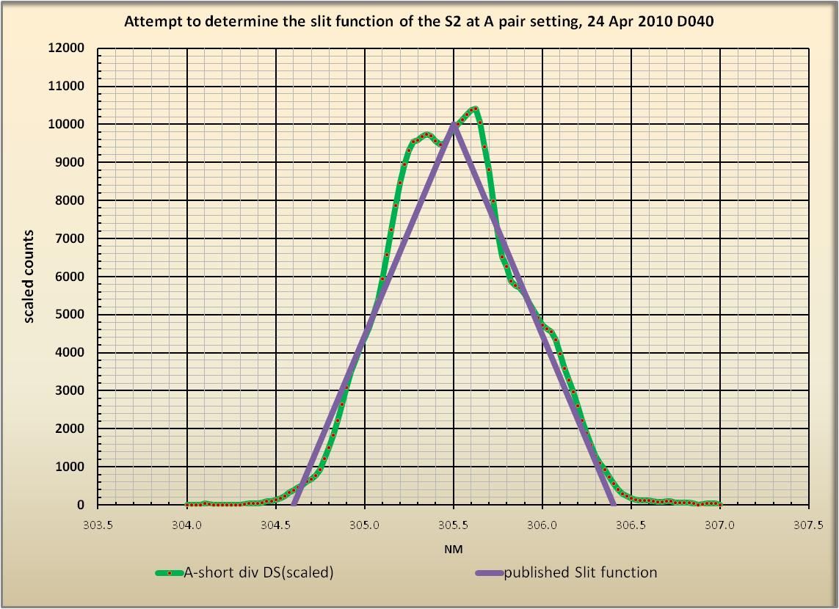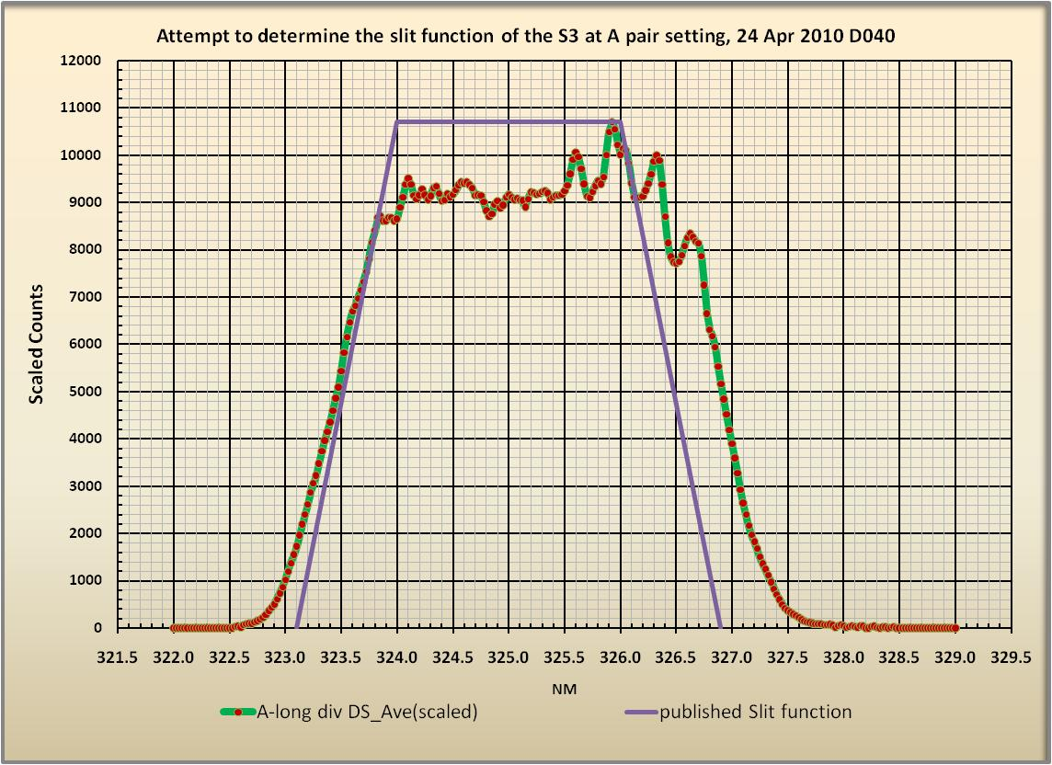

C-pair
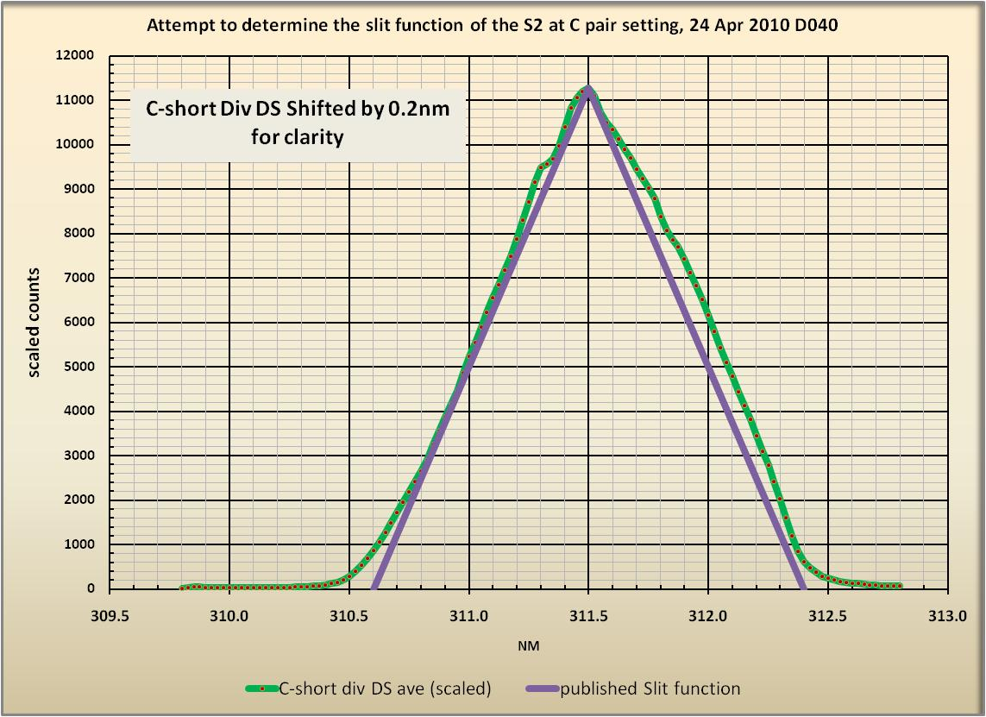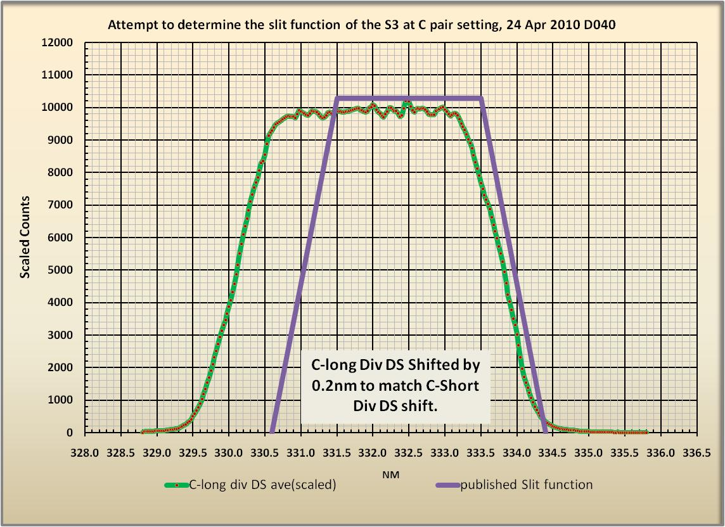

D-pair
