Fig 8a; Count ratio of 323.2 nm and 303.6 nm wavelengths aginst zenith angle. Day 190, 1996.
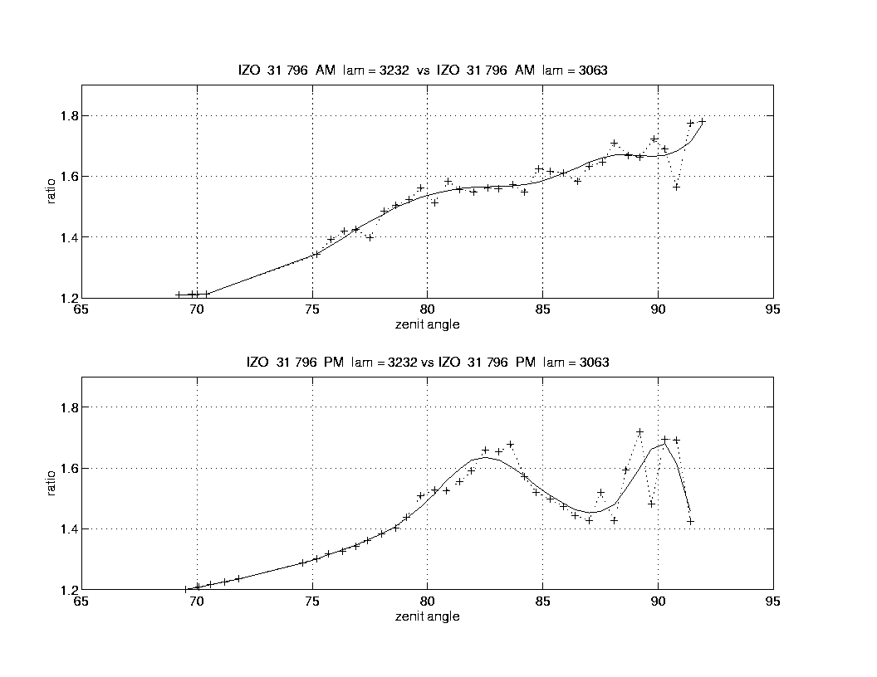
Fig 8b; Count ratio of 323.2 nm and 303.6 nm wavelengths aginst zenith angle. Day 213, 1996.

